ASSOCIATE REGISTRATION FORM

Welcome and thank you for expressing an interest in becoming an Associate with Every-One.

It is important to us that we work with people that understand and believe in what we want to achieve as a Charity. To find out more about what we are doing now, please check out our website at www.every-one.org.uk . We are a developing organisation with ambitions to grow a wide range of support projects and services for carers and the people they care for. Our work programme is therefore wide and varied and to be able to succeed, we need to work with a diverse set of employees and Associates.

We therefore need to know what you are passionate about, what types of work areas are of greatest interest to you and what skills and experiences you bring with you. We will hold your details so that if and when an opportunity arises, we can get in contact and look for a match.

By completing this form, we cannot guarantee you any work opportunities, but as we grow, we very much hope to increase our chances of working with you in the future.

If you have any questions, please do not hesitate to contact us. Please also stay in contact with us through our website and social media platforms:

Once completed please return to:

Email: vicky.thomson@every-one.org.uk
Post: Vicky Thomson, Chief Executive, Every-One,
5 The Stables, Wellingore Hall, Wellingore, Lincoln LN5 0HU

You are welcome to also attached a copy of your CV to provide some of the information requested.

Thank you for taking the time to share your details with us, it is very much appreciated.
Best wishes
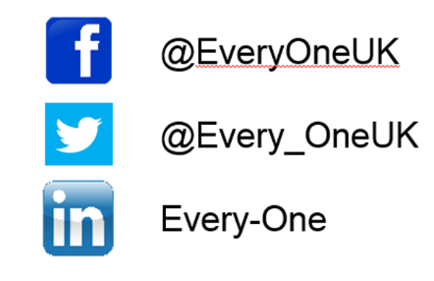
Vicky Thomson
Chief Executive
PERSONAL DETAILS

Name:

Company Name (if appropriate):

Correspondence Address & Post Code:

Email:

LinkedIn Profile:

Website:

Contact phone number:

Additional needs:

Do you agree to the use of your photograph to be used for promotional purposes? | Yes | No
Do you agree to your details being stored by Every-One and not passed to any other organisation without your permission? | Yes | No
GETTING TO KNOW YOU

What interested you in becoming an Associate of Every-One?

What are you currently working on?

What skills and experiences do you have that you think would be most relevant to working with Every-One?

What have you done that you are most proud of?:

What does ‘wellbeing’ mean to you?

What type of things would you really love to do but the opportunity has never arisen?:

What type of things would you now want to be offered?:

PRACTICALITIES

What is your current availability?

Please detail the minimum / maximum hours you would be interested in working, any days of the week you are not available for, any periods through the year you are not available etc.

What are your working preferences?

Please detail whether you would prefer to work from home or in our offices, whether you would prefer short term pieces of work or longer term projects etc.

What are your charges?

Please detail the minimum hourly / daily rate you would accept and any scales of charges you apply.

Would you be willing to provide any support to Every-One on a voluntary basis?

This might include investing some time in supporting the development of funding bids or production of resources which may lead to paid opportunities.

REFERENCES (Please give details of two referees that we can contact)

Referee 1.
Name & Address:

Position:

Email:
Relationship to you:

Referee 2.
Name & Address:

Position:

Email:
Relationship to you:

PREVIOUS WORK EXPERIENCE AND QUALIFICATIONS

If you have attached a CV that includes this information, you can miss out this section.

Details of your work history:

Details of your training or qualifications:

